The Effects of Earmarked Property Taxes on Education Spending: Evidence from Michigan
Matthew Guzman
Abstract: Substantial research has investigated the effects of conditional or earmarked grants on local spending. Using data on earmarked special education property taxes in Michigan, this paper presents evidence of how local spending changes in response to earmarked funding from local sources. I find that special education property taxes increase special education revenues and special education salaries, and local governments transfer the majority of funding to local school districts. At the local level, additional revenues “leak” to general education spending. This suggests that while conditional grants are effective tools to increase targeted public spending, school districts treat conditional grants as fungible.
Introduction
Conditional or earmarked grants have emerged as an effective tool to induce spending in public finance (Thornton, 2012; Mehririz & Marceau, 2014). Conditional grants comprise grants in aid that include stipulations and reporting requirements regarding how funds may be spent, and research demonstrates that conditional grants are more effective for increasing targeted public expenditures than unconditional grants (King, 1984; Bradford & Oates, 1971b). In contrast to unconditional grants, local governments are less likely to decrease local tax effort to offset additional revenues following the implementation of conditional grants (Brun & El Khardi, 2016; Dye & McGuire, 1997).
While substantial research has investigated the impacts of earmarked grants on local spending, less research has considered the effects of earmarked property taxes. Like conditional grants, earmarked property taxes are conditional revenue sources that may only be spent on specific local government functions. These types of taxes are less common than conditional grants or dedicated sales taxes, but they are growing across the U.S. in the forms of property taxes for community colleges (Dowd & Grant, 2006), mental health services taxes (Purtle et al., 2023), and property taxes in support of local arts and culture (Rushton, 2004, 2005).
Using the timing of local property tax changes in Michigan, this paper estimates the effects of increased, earmarked property taxes for special education on local spending. In addition to property taxes for general education, Michigan school districts also levy earmarked property taxes for special education and career and technical education. Revenues from these additional taxes are highly restricted, and they can only be spent for the educational function for which they were approved. Moreover, when voters approve new property taxes, school districts receive sudden, large increases in local revenues for special education. I argue that the timing of these property tax changes provides plausibly exogenous year-over-year increases in conditional aid for special education.
I find that the adoption of new special education property taxes leads to between a $300 and $400 increase in conditional per-pupil revenue. Following this increase, ISDs increase special education spending by a smaller $124 to $172, and they transfer the remainder of the revenue increase to local school districts. Notably, estimates of the change in total special education spending are not robust, although this is driven by offsetting increases in special education salaries and decreases in purchased services and supplies in treated ISDs.
Following the transfer of special education revenues to local school districts, I find that local school districts increase non-special education salaries, decrease expenditures for purchased services, and increase transfers back to ISDs. This suggests that like other conditional grants, earmarked property taxes may “leak” to other education purposes, although they do increase spending for their intended function substantially. This suggests that school districts treat conditional revenue increases as fungible even when conditional grants are generated by voters themselves and have exceptionally high accounting oversight.
Michigan’s unique structure of special education finance provides an ideal context in which to study the effects of earmarked property taxes. In addition to property taxes for general education funding, Michigan Intermediate School Districts (ISDs) also levy property taxes for specific educational functions including special education and career and technical education. Like other taxes, these earmarked education taxes must be renewed by voters when they expire, and they are labelled with their specific educational functions in the text of the ballot initiative.
To understand the effects of special education property tax adoption on local finances, I estimate staggered two-way fixed effects (TWFE) models using a continuous treatment. Drawing on Wooldridge (2025) and Callaway et al. (2024), I estimate an extended TWFE model with linear and quadratic functional forms of the continuous treatment, and I use these to determine the effect of increased property taxes on special education revenues, special education expenditures, and expenditures for non-special education purposes.
This paper proceeds as follows. Section II describes research on intergovernmental grants and conditional grants in aid, Section III describes the context of Michigan special education finance, Section IV presents the theory of categorical grants for school districts, Section V describes the local property tax data, Section VI describes the extended TWFE method with continuous treatment, Section VII presents results and robustness checks, and Section VIII concludes.
Intergovernmental Grants and Conditional Grants
Substantial research has investigated the effects of intergovernmental grants to state and local governments (Hines & Thaler, 1995). Bradford & Oates (1971a, b) predict that increases in government grants would crowd out state and local spending, and as a result, grants would be ineffective to increase public expenditures. Early research contradicted this result and suggested that grants increased public expenditures by a range of 25 cents per dollar of grant funding up to a $1 increase in per dollar of grant funding (Inman, 1971; Gramlich & Galper, 1973; Hines & Thaler, 1995).
This so-called “flypaper effect” represents an empirical puzzle. While additional resources from grant aid should be equivalent to increased income for the median voter, resources in the form of grant aid have different effects on consumption. Bradford & Oates (1971b) describe this in detail, and they demonstrate that an unrestricted intergovernmental grant is theoretically equivalent to providing the median voter with a lump sum grant equal to the total grant multiplied by their local tax share. As a result, the net effect of the tax change should be equivalent to increasing the median voter’s income by the amount of the grant, and the original local budget would be assumed to be the preferred allocation to public spending (Hines & Thaler, 1995).
While early research struggled to explain the flypaper effect, more recent research finds that after accounting for endogeneity, the spending following the receipt of a grant is much more aligned with the median voter theory (Knight, 2001). Further, Singhal (2008) provides evidence that the flypaper effect may be induced by dynamic interactions between politicians and interest groups, and Dahlby (2010) demonstrates that the flypaper effect may be observed in settings with distortionary taxes as well. This research suggests that increases in government spending may not be violations of the median voter theory, but rather the result of additional contextual factors that limit the ability of governments to treat revenues as fungible.
In addition to research on intergovernmental transfers generally, research has also explored how school districts respond to grant funding as well (Fisher & Papke, 2000). For example, Duncombe & Yinger (1998) find that a $1 increase in state aid is associated with a $0.33 increase in school spending. This is greater than the predicted increase associated with a $1 increase in average income in a school district, but still less than the full amount of the grant. Similarly, Dee & Levine (2004) find that increases in state aid in Massachusetts following a 1993 school finance reform induced increases in total per pupil revenues, although increases were attenuated by decreased local tax effort. Cascio et al. (2013) also find that an increase in federal grant aid to school districts induced a $0.50 dollar increase per dollar of aid to southern school districts in the 1960s. Like grants to local governments, this research in this area suggests that “general unrestricted state grants for education increase local spending, but not dollar-for-dollar,” (Fisher & Papke, 2000; p. 160).
Beyond unconditional grants in education, some studies have also explored the effects of conditional grants to school districts. In Michigan, Addonizio (1997) finds that increased state funding for economically disadvantaged students increased school spending for those students by $0.61 per dollar of grant funding, and the remaining expenditures “leaked” to other general fund expenditures. Dye & McGuire (1997) similarly find evidence of revenue fungibility in response to property tax caps results in the Chicago area as well. Fisher & Papke (2000) conclude that while there is relatively less research related to conditional grants in education, the limited evidence suggests that they are effective for increasing spending for their intended purposes.
In this paper, I explore a property tax change that is most similar to a restricted categorical grant. In Michigan, property taxes for special education must only be spent on special education functions, and these expenditures are subject to rigorous audits by the State. In contrast to prior research, this type of funding is more similar to a voucher. Following Bradford & Shaviro (2000) and Shah (2006), I develop a simple theoretical model of these dynamics, and I find that ISDs adjust financial allocations to special education in alignment with property tax conditions. In addition, I find evidence of “leakage” similar to that described in Craig & Inman (1982) at the school district-level as transfers of special education revenues to school districts translate into larger increases in non-special education spending. These “leaks” are largest among rural school districts that are likely to have lower capacity to provide special education services.
While Michigan is the only state that uses this structure of earmarked property taxes for special education, this research has applications to other areas of public finance as well. Earmarked property taxes are common in education, and almost all school districts use property taxes to fund capital expenditures (Biasi et al., 2024). Outside of education, earmarked property taxes for community mental health services have grown since the Covid-19 pandemic, and these property taxes similarly support specific local health services. Finally, a small amount of research has also explored local property taxes for local culture and arts, although these property taxes are far less common (Rushton, 2004, 2005).
Michigan Education Finance
Unlike other states, Michigan school districts are primarily funded through state sources. As a result of the Proposal A ballot initiative in 1994, variable local property taxes for general education purposes were replaced by a uniform statewide property tax and statewide sales taxes (Cullen & Loeb, 1999; Papke, 2005, 2008). This change limited the abilities of local school districts to raise general revenues for education, and this policy endeavored to equalize spending across high and low-income school districts (Addonizio et al., 1995).
[Figure 1 about here]
Average per pupil revenues in Michigan school districts are presented in Panel A of Figure 1. This figure illustrates the average total state, local, and federal general education revenues between the 1990-91 and 2024-25 academic years, and the sharp increase in state-provided funding for general education functions is evident beginning in the 1994-95 academic year. At this time, Michigan school district operating property taxes were capped at 18 mills, relative to an average of 33.4 mills prior to the change. Average per pupil revenues declined in real terms between the 2001-02 academic year and the 2014-15 academic years, although total revenues have increased since that time in part due to higher federal revenues during the COVID-19 pandemic (Burns & Guzman, 2025).
Panel B of Figure 1 presents average per pupil expenditures in Michigan for non-special education instruction, non-special education support, and special education functions. Expenditures track closely with total revenues, although per pupil instruction expenditures have been more stable than per pupil support expenditures. Per pupil expenditures for special education have increased since 1991, although these have been relatively stable since 2011 relative to per pupil support expenditures (Burns & Guzman, 2025).
While school districts may use any of their general revenues to provide special education, special education services are substantially more expensive relative to general education services (Chambers et al., 2005; Parrish et al., 2015). Across the U.S., school districts spend an average of $13,047 more for the average student with a disability relative to a general education student, and these additional expenditures vary dramatically by disability (Chambers et al., 2005). In addition, students with disabilities have strong legal protections under IDEA to ensure that school districts provide all services necessary for them to receive a “free and appropriate public education,” (IDEA, 2019). Federal funding is provided primarily through IDEA, although this funding covers only about 15% special education spending in the U.S. (Kolbe, 2019; Kolbe et al., 2022). In addition, the State of Michigan reimburses school districts for 28.6% of their total special education expenditures in each academic year, and school districts must fund all other special education expenditures through local sources.
In contrast to general education revenues which are primarily controlled by the state, Michigan school districts face significant variation in their abilities to raise revenues for special education. The State's 538 traditional public school districts and 287 charter school districts are organized into 56 Intermediate School Districts (ISDs), and these administrative groups of geographically neighboring districts share resources for special education services. In addition to federal and state revenue streams for special education, ISDs levy property taxes specifically to finance special education in their constituent districts.
A map of one ISD is provided in Figure 2. This figure illustrates Ingham ISD, and this ISD is comprised of 12 constituent districts in central Michigan. While each of the 12 constituent districts operates independently with their own general education revenues and administration, the ISD collects revenues from earmarked special education property taxes as well. The ISD may use the revenues from these taxes to support ISD-wide special education programs and supplement local school district special education programs, or they may transfer the revenues from this property tax directly to school districts as well. This structure enables collaboration and returns to scale as ISDs typically provide support for the highest need disabilities directly (Arsen et al., 2019).
[Figure 2 about here]
To raise revenues for special education, ISDs can renew or increase special education-specific property taxes subject to an ISD-wide vote. Property taxes for special education must be submitted to voters, and these taxes are typically adopted for between 5 and 20 years. Taxes must be reauthorized by voters when they expire, and ISDs may choose any property tax level to place on the ballot subject to a state maximum. This structure can create sudden, sharp increases in local funding for special education when ISDs adopt new, larger property taxes to support special education.
An example of the revenue effects of this property tax increase is presented in Figure 3. This figure presents the per pupil revenues for special education in one example ISD, and this ISD adopted a new property tax for special education in 2015. In this year, local revenues for special education increased by approximately $400 per pupil. I leverage this variation to determine whether and how additional funding for special education impacts ISD-level and school district-level finances.
[Figure 3 about here]
While all ISDs are legally allowed to raise property taxes for special education through a ballot initiative, ISDs vary dramatically in the willingness of their citizens to adopt these changes. Among the 56 ISDs, 26 have adopted new special education property taxes since 2003-04 academic year. Among those that haven't adopted a new special education property tax during this time, some have never adopted a property tax for special education since the establishment of the ISD structure in Michigan in the early 1960s. Further, among those that have adopted new property taxes, some have adopted new property taxes as many as four times during this period.
These differences in ISDs’ practical abilities to implement this policy create analytic challenges. Although any ISD could adopt a new property tax at any time or renew a property tax, some ISDs have not done so during my sample period, and some have not adopted a property tax for special education in recent memory. To account for these, I re-estimate my primary models using the sample of ISDs that have passed a special education property tax at least once during my sample period. In addition, I also incorporate synthetic difference-in-differences models in my robustness checks following Arkhangelsky et al. (2024). To the extent that never treated ISDs are different from treated ISDs on unobservable characteristics, these approaches will mitigate bias in the estimate of the average treatment effect.
Theoretical Background
To illustrate the effect of this policy change, Figure 4 presents the ISD’s budget constraint with an earmarked property tax for special education. In this simplified example, the x-axis represents per pupil expenditures for special education, and the y-axis represents all other per pupil expenditures. The solid black line illustrates the ISD’s budget constraint prior to the property tax change. Here, the ISD may choose any allocation along the black line, and the restricted grant for special education may not be spent on non-special education functions.
[Figure 4 about here]
Following the property tax change, the ISD moves to the blue budget constraint in Figure 4. This does not change the ISD’s budget constraint for non-special education, although the ISD is able to spend more on special education after the tax change.
In this example, ISDs would be predicted to shift their allocations of spending on special education and non-special education purposes. Given strong administrative oversight of revenues for special education, fiscal fungibility is unlikely in this context and ISDs would be predicted to spend additional earmarked revenue for special education. Nevertheless, understanding the uses of the additional funds could inform predictions regarding other similar earmarked property taxes.
Data
To determine the impacts of earmarked property taxes for special education on school district finances, I use public and private datasets provided by the Michigan Department of Education (MDE) between the 2003-04 and 2024-25 academic years. ISD-level special education property tax rates are contained in annual Michigan State Aid Financial Status Reports, and I use these to identify all ISD-level special education property taxes increases. In addition, I cross-reference these with annual county-level property tax reports to confirm tax increases. This implies that treatment is defined as an increase in property tax rates induced by a special education property tax election, and not only a property tax election itself.
In addition to these property tax rates, I leverage ISD-level and school district-level financial data from the Michigan Education Research Institute (MERI). These datasets include entity-level revenue and expenditure data. Revenues are separated by their source (local, state, or federal) and their intended function if the revenues are restricted, and I use these to isolate total earmarked revenues for special education and local property tax revenues for special education. In addition, expenditures are separated by their educational purpose including instruction or support functions, and special education comprises a subset of these expenditures for special education salaries, benefits, supplies, and purchased services. In addition, expenditure data include information on transfers of restricted revenues between entities, and I use these to isolate transfers of special education revenues from ISDs to local school districts.
I make two primary sample restrictions on the sample of ISDs. I observe re-treatment of ISDs during my sample period as old special education property taxes may expire prompting ISDs to adopt new property taxes. This leads to re-adoption of special education property taxes for some ISDs during my sample period. To account for this, I drop ISD-year observations in any time period after a secondary treatment. In addition, I drop all observations for one ISD that is fully operated by the State of Michigan. This ISD is funded by the state and has a different administrative structure relative to other ISDs in the state.
I also leverage student-level data from MERI between the 2002-03 and 2024-25 academic years to identify student demographics and enrollment levels in each ISD and school district. These data contain each student’s school district and Intermediate School District as well as their gender, race or ethnicity, English learner status, and their special education status. Using these data, I calculate the total full-time equivalency enrollment in entity in each academic year to convert revenues and expenditures to per pupil terms.
Averages and standard deviations for ISD-level per pupil revenues and expenditures are provided in Table 1 separately for treated ISDs that experienced a property tax change during my sample period and control ISDs that did not. Total per pupil revenues are comprised of local, state, and federal revenues in the ISD divided by the total full-time equivalencies of all students in the ISD. Treated and control ISDs had very similar total revenue streams during my sample period. Earmarked revenues for special education represent a subset of these total revenues, and these are generated via local property taxes for special education, state aid, and federal aid. Treated ISDs generated approximately $150 more per pupil than control ISDs in earmarked special education revenues during my sample period, and this is almost entirely driven by differences in local per pupil revenues. Local special education revenues constitute approximately 42% and 47% of total special education revenues in control and treated ISDs, respectively.
[Table 2 around here]
Considering per pupil expenditures for special education, control ISDs spend $1,416 per pupil for special education relative to $1,437 in treated ISDs. Treated ISDs transfer approximately $150 more of this revenue to school districts on average, and they have higher average special education property tax rates as well. In addition, the average special education property tax increase is 0.61 mills among treated ISDs.
The lower panel of Table 1 presents averages and standard deviations for student demographic characteristics during my sample period. Approximately half of Michigan students are women in my analytic sample, and most Michigan students are White. 51% of Michigan students were identified as economically disadvantaged in control ISDs relative to 49% in treated ISDs, and 17% of Michigan students were identified as students with disabilities in both treated and control ISDs.
Methods
Although a regression discontinuity analysis of close elections is common in this context, this type of analysis is infeasible in my sample. I only observe 10 failures of a special education property tax during my sample period, and this small number makes an analysis of close passes and fails difficult. Further, ISDs that fail a property tax will typically place another property tax on the ballot in the next election cycle. This implies that even if voters fail a property tax and their ISD remains untreated, their ISD will likely become treated in a subsequent year.
Rather than compare outcomes of ISDs with close elections, my estimation strategy compares early adopters of this policy with later adopters. Using a staggered difference-in-differences approach, I estimate modified extended two-way fixed effect (ETWFE) models for the panel of Michigan ISDs following Wooldridge (2025). Given my sample size, I make several restrictions from the fully saturated model, and I also modify the estimating equation to account for the continuous nature of the treatment. My main estimating equation takes the following form:
$$y_{it}=β_{0}+\sum_{g}{γ_{g}Cohort_{i}×f\left(TaxIncrease_{it}\right)+{ΩX_{it}+α}_{i}+δ_{t}+ε_{it}}$$
For each ISD $i$ in each year $t$, $Cohort$ represents a constant indicator for the first year in which an ISD becomes treated, $TaxIncrease$ represents a time-varying treatment variable equal to 0 in years before treatment and equal to millage change that takes effect when the ISD becomes treated, $X_{it}$ represents a vector of time-varying, ISD-level covariates, $α_{i}$ represents an ISD-level fixed effect, $δ_{t}$ represents a year fixed effect, and $ε$ represents a normally distributed error term.
In this model, I explicitly account for staggered adoption by interacting my continuous treatment variable with indicators for each cohort of treated ISDs. This yields cohort-specific estimates of the effects of increasing property taxes, and I aggregate these estimates taking the weighted average where weights are defined by the number of treated units in each cohort $N_{g}$ divided by the total number of treated units $N$.:
As a result of my sample size, I restrict treatment heterogeneity by not interacting the treatment variable with covariates, and I also do not interact covariates with unit or time fixed effects. I relax some of these restrictions in robustness checks, and they do not affect the estimates.
In addition to the restricted version of Wooldridge (2025)’s ETWFE model, I also extend this model to incorporate a continuous treatment indicator (Callaway & Sant’anna, 2024). To account for this, I test linear and quadratic functional forms of the $TaxIncrease$ variable, and I conduct robustness tests using a “levelled” treatment definition in which I replace continuous treatment indicators with binary indicators for “high” and “low” dosage treatments. Estimates of the effect of the continuous treatment provide the average causal response of the outcome to the increase in the property tax.
In addition to simple aggregate effects, I also estimate an event study model of the effect of special education property tax adoption as well. Due to my sample size, I again restrict treatment heterogeneity, and I do not interact event study indicators with treatment cohorts. This model takes the form of Equation (3):
$$\begin{aligned}y_{it}=β_{0}+\sum_{e}{γ_{e}Event_{e}×f\left(TaxIncrease_{it}\right)+EverTreated_{i}+δ_{t}+ε_{it}} \#(3)\end{aligned}$$
All variables are defined as in Equation (1), and I interact the treatment indicator with event time dummies $Event_{e}$ which correspond to the number of years until treatment. In addition, to avoid overfitting, I replace unit fixed effects in this model with a binary $EverTreated$ indicator that is equal to 1 for all units that are ever treated. As with aggregated estimates, I compute unconditional standard errors for these estimates as well.
Results
Local Property Tax Revenues
Table 2 presents the average causal response of per pupil local special education revenues from Equation (1). Using a linear functional form of the special education millage increase in column (1), I find that a 1 mill increase in the special education property tax is associated with a $315 increase in per pupil local special education funding. Adding covariates in column (2), this estimate increases to $377. Of the covariates, only the proportion of students with disabilities in an ISD and the total enrollment in the ISD are related to local property tax revenues for special education. A 1 percentage point increase in the proportion of students with disabilities is associated with a $9.49 increase in per pupil local revenues for special education, and a 1% increase in total enrollment in an ISD is associated with a 6% decrease in per pupil revenues. Notably from Table 1, the average millage increase during my sample is 0.61, so the average treatment on the treated according to column (2) is $230.
Accounting for potential non-linear treatment effects, columns (3) and (4) re-estimate columns (1) and (2) using a quadratic functional form of the special education property tax increase. To include two treatment indicators, treated cohorts must include at least two treated ISDs, and this accounts for the smaller sample sizes in these columns. These estimates provide somewhat smaller estimates of the effect of increasing property taxes on per pupil special education revenues.
Because 9 of 15 treated cohorts are singletons, I cannot estimate the quadratic functional form of the treatment intensity with all ISDs. As a result, the estimates in column (2) of Table 1 comprise my preferred estimates. This model accounts for treatment heterogeneity by cohort in a regression framework, and it incorporates the continuous treatment in a linear functional form.
Figure 5 presents an event study of per pupil local revenues for special education using estimates from Equation (3) with a linear functional form of the treatment intensity. This illustrates very limited pre-trends in local special education revenues prior to the property tax adoption, and I observe an immediate increase following the adoption of the property tax. Note that revenues in the left-out period appear to be slightly higher than in the rest of the pre-period, although this is likely because property taxes don’t align precisely with school district fiscal years. As a result, some revenues from the property tax change may be collected in the left-out year. In addition, per Michigan state law, taxes may not collect more than they were originally approved to collect, so per pupil local special education revenues naturally decline over time as they are adjusted down as property values increase. This is evidenced by the decreasing trend in local revenues, although this is not evident in the pre-period as treated and control ISD revenues appear to change at the same rate prior to the tax change.
Table 3 presents robustness checks of my main specification with varying model specifications, covariates, and sample restrictions. Column (1) of this table presents my base model with all covariates and linear, continuous treatment from column (2) of Table 2. Column (2) of this table includes a lag of average special education revenues, and this decreases the estimate of the effect of property tax adoption to $239 per pupil. As in Table 1, this suggests that some of the higher property taxes are explained by the fact that treated ISDs have higher local per pupil revenues for special education in general. Column (3) of Table 3 uses a Poisson regression to account for the non-negative nature of the outcome variable. This provides a slightly larger estimate than my main model. Column (4) interacts cohort-time demeaned covariates with the treatment variable following Wooldridge (2025), and this increases the estimated effect further to a $404 increase in per pupil local revenues for special education.
Column (5) of Table 3 re-estimates the model with a binary treatment instead of a dosage estimator. In this case, there is no assumed functional form of $TaxIncrease$, and the estimate is equivalent to the average treatment on the treated. In other words, this estimate is not the effect of a 1 mill increase, but the average effect of adopting any property tax for special education on ISD revenues. This is substantively smaller and more precise than my main estimate, and this indicates that the average effect of adopting an earmarked property tax for special education is a $181 increase in per pupil revenues for special education. Column (6) of Table 3 presents the estimate using a TWFE estimator that does not include interactions with the cohort indicators, and this estimate is very similar to my main estimate. Next, column (7) re-estimates the model using only a balanced panel of ISDs, and column (8) uses a stacked estimator following Cengiz et al. (2018) and Wing et al. (2024). These estimates are largely in line with my main estimate.
Finally, I estimate three alternative models of Equation (1). In Column (9), I estimate the weighted average slope (WAS) estimator following de Chaisemartin & de Hautefouille (2020). This estimator is uniquely suited to model continuous treatments, staggered adoption, and possible violations of parallel trends, and the estimate is only slightly smaller than my main estimate. In column (9), I also estimate the model with binary treatment using a synthetic difference-in-differences estimator following Arkhangelsky et al. (2024), and this gives a smaller but still significant effect that is aligned with the binary treatment ETWFE estimator. In column (11), I re-estimate Equation (1) replacing the functional form of $TaxIncrease$ with two binary indicators for low and high dosage treatments. The low dosage treatment indicator is equal to 1 if the millage increase from the property tax change is less than 0.5 mills, and the high dosage indicator is equal to 1 if the increase is greater than 0.5 mills. This analysis indicates that larger millage increases are associated with larger increases in revenues.
In addition to these specifications, I estimate similar robustness checks for the sample of ever-treated ISDs in Appendix Table A2. In the case that control ISDs differ on unobservable characteristics relative to treated ISDs, comparing not-yet-treated units to treated units may provide a better control group. These estimates are very similar to estimates using a never treated control group in Tables 2 and 3.
The results of these additional specifications corroborate my main finding that a 1 mill increase in special education property taxes generates between a $300 and $400 increase in per pupil local revenues for special education, although the magnitude of the effect may be larger or smaller depending on the exact size of the property tax change.
Impacts on Special Education Expenditures and Transfers
While adopting new property taxes for special education has a strong positive impact on earmarked revenues for special education, the impacts of these additional revenues on spending are not clear. ISDs may use additional revenues to supplement their own special education programs, and these expenditures could be observed as increased salaries, benefits, supplies, or services for special education. Alternatively, ISDs may transfer additional funding from local property tax revenues to constituent local school districts. In this case, the additional revenues would support local school districts to provide their own special education programs.
Table 4 presents the average causal responses of ISD-level spending for special education and transfers of earmarked special education revenues. Column (1) of this table presents the fully specified model with a linear functional form of treatment, and column (2) presents this model with a quadratic treatment. The estimates from columns (1) and (2) suggest that ISDs do increase spending for their special education programs following the adoption of new property taxes, although by less than the full value of the property tax. This is consistent with research on other restricted education grants (Fisher & Papke, 2000). Considering the linear model in column (1), a 1 mill increase in a special education property tax causes ISDs to increase spending for special education by $124 per pupil. Figure 6 also presents an event study model of ISD-level special education expenditures, and this provides some evidence that expenditures for special education at the ISD-level increase over time. Notably however, most alternative specifications of this model in Appendix Table A3 are not robust. This suggests that the average ISD might increase total special education spending slightly following the tax change, but the effect varies dramatically by ISD.
Considering transfers of special education revenues, columns (3) and (4) present linear and quadratic models of the effects of special education property taxes as well. Using a linear functional form of the treatment variable, Column (3) of Table 4 indicates that ISDs increase transfers of special education funding to school districts by $195 per mill of increased property tax. This comprises the majority of the increased property tax revenue. This suggests that ISs primarily use special education property tax revenue to support their constituent school districts. This may not be surprising. By transferring revenues, ISDs can alleviate the financial requirements of local school districts to support special education from general revenues. Disbursing additional revenues to local school districts could also increase the targeting of spending to align with local needs.
I provide robustness checks of the effects of earmarked property taxes for special education transfers to local school districts in Appendix Table A4. Appendix Table A4 presents corresponding robustness checks for ISD-level transfers of special education revenues to local school districts. In contrast to Appendix Table A3, almost all robustness checks remain positive and significant, although estimates vary in magnitude. Using a synthetic model returns an insignificant estimate, although this may be due to the smaller sample size in this model.
While the lack of robustness for special education spending may be surprising, total expenditures for special education could obscure changes in the composition of spending as well. To explore this mechanism, Table A5 estimates changes in ISD-level per pupil special education spending separated by educational purposes following the adoption of an earmarked property tax. This table suggests that changes in spending are comprised of increases in salaries and benefits and corresponding decreases in expenditures for purchased services and supplies. This suggests that increases in earmarked special education funding may translate into salary increases and potentially hiring changes that may not change affect aggregate spending.
Impacts on Local School District Finances
To understand the effects of additional transfers of special education dollars at the local level, I re-estimate Equation (1) with a school district-level sample. This sample is comprised of the public school districts within ISDs in my main analytic sample, and I remove charter school districts from this sample as they have different financial structures and abilities to support special education. In addition, I remove observations for one school district that appears to have extremely high outlying special education expenditures. Appendix Table A1 provides a summary of the sample data for these school districts.
Table 5 presents estimates using local school district per pupil special education expenditures and non-special education expenditures as outcomes. These models use the same estimating equations as the ISD models, although these are weighted by school district-level enrollment and they use school district fixed effects. As these school districts receive additional funding for special education from the ISD, this additional funding could enable them to change spending patterns to align with new revenues.
Columns (1) and (2) of Table 5 estimate the effects of new property taxes on per pupil special education expenditures at the school district-level. I do not find any change in special education spending using either model. These models indicate that the adoption of a new property tax for special education has a negligible impact on school district-level spending for special education.
In contrast to special education expenditures, columns (3) and (4) of this table present estimates of the adoption of a new property tax on per pupil expenditures for non-special education functions, and I find positive and significant estimates in both specifications. The linear model in column (3) of Table 5 indicates that a 1 mill increase in special education property taxes causes local school districts to spend $305 more per pupil for non-special education purposes, and the quadratic model in column (4) estimates a smaller $141 increase in spending. This suggests that school districts may not use additional revenues to increase spending for special education, but rather additional revenues replace expenditures that would have previously been used for special education.
To explore these non-special education expenditures further, Table 6 separates non-special education expenditures from column (3) of Table 5 by educational purpose including salaries, benefits, purchased services, supplies, and transfers to other districts or ISDs, and other expenditures including debt service. This table reveals substantial variation in non-special education expenditure trends following the adoption of the property tax. Following a 1 mill property tax increase for special education, school districts would be expected to increase spending on salaries, benefits, and transfers to other school districts and ISDs, and they would be expected to decrease expenditures on purchased services. If school districts were previously contracting out services to private companies, this may reflect more centralized resources for special education following the tax change. In addition, if ISDs provide greater services following the adoption of the property tax change for special education or other programs, then this could explain the increase in expenditures for transfers to districts and ISDs following the change.
I explore potential heterogenous effects of local property tax adoption on spending in Appendix Table A8. Here, I re-estimate the models in Table 6 separately for school districts interacting the treatment indicator with a binary indicator for whether school districts are rural. This table reveals substantial heterogeneity of spending effects by district characteristics. Rural school districts tend to increase non-special education salaries following the property tax change, although there is a more muted change in expenditures for purchased services and transfers of resources back to the ISD. This indicates that spending effects may be the largest in urban or suburban school districts where ISDs find returns to scale from additional investment in special education.
Applying the same theoretical framework as in Figure 4, the results in Tables 5 and 6 indicate that additional revenues for local school districts from earmarked special education property taxes are fungible. Additional revenues are typically used to increase non-special education salaries and to support additional programming at the ISD-level. To the extent that greater centralization of special education or other education functions supports students, this may be a valuable change for school leaders and policy makers.
This research has two primary implications for research and policy. First, this adds to the literature on school district spending of unrestricted grants. Prior research finds that restricted education grants increase spending for the target function, but by less than the full amount of the grant. I find a similar result in a context in which school districts cannot respond by decreasing local tax effort, and this is primarily due to “leakage” of grant funding to general funding purposes. This echoes findings by Addonizio (1997) and Fisher & Papke (2000).
Regarding policy implications, policymakers working to increase funding for special education may need to increase funding dramatically to see change, or they may need to implement greater oversight of special education revenues at the local level. Given the strong legal protections for students with disabilities, this finding may indicate that ISDs and local school districts are already meeting their obligations to students prior to the tax change. Nevertheless, future research should also explore whether increase expenditures for special education improves outcomes for student with disabilities as well. If additional expenditures positively impact these students, then these positive impacts need to be weighed against positive impacts from increasing expenditures for students without disabilities as well.
Conclusion
Given the constraints on state and federal funding for special education, dedicated local property taxes represent an effective mechanism to support special education programs. Adopting new property taxes for special education increases local revenues for by $300-$400 per pupil on average, and these new revenues are observed immediately. ISDs use some of this additional funding ($124 per pupil on average in my preferred specification) for special education programs, and they transfer the majority of this funding ($195 in my preferred specification) to local school districts to support their special education programs.
While local school districts observe immediate increases in revenues from the ISD-level transfers, they do not spend additional revenues on special education programs on average. Instead, I find evidence that they reallocate non-special education expenditures to increase spending for non-special education salaries, and in urban and suburban districts, they increase transfers to other educational entities. This indicates that additional revenues support greater centralization of special education and other educational programs at the ISD-level, although this effect is not felt as strongly among rural school districts.
While this finding may be counterintuitive, it is important to emphasize that this structure is entirely legal and sound. If anything, this suggests that local school districts already support special education to the extent required under IDEA and individualized education plans. As a result, additional funding offsets the resources being devoted to these programs and frees up funding to be spent in other areas. That said, if policy makers aim to increase funding for special education through local funding mechanisms, then greater oversight may be required to ensure that funding is not used to offset current special education expenses. Alternatively, policy makers could also use state and federal funding for special education which are significantly more regulated than local dollars.

References
Addonizio, M. F. (1997). The efficiency of state categorical funding for children educationally at risk. Planning and Changing, 28(1 & 2), 26–56.
Addonizio, M. F., Kearney, C. P., & Prince, H. J. (1995). Michigan’s High Wire Act. Journal of Education Finance, 20(3), 235–269.
Arkhangelsky, D., Athey, S., Hirshberg, D. A., Imbens, G. W., & Wager, S. (2021). Synthetic difference-in-differences. American Economic Review, 111(12), 4088–4118. https://doi.org/10.1257/aer.20190159
Arsen, D., Delpier, T., & Nagel, J. (2019). Michigan School Finance at the Crossroads: A Quarter Century of State Control. Michigan State University. https://education.msu.edu/ed-policy-phd/pdf/Michigan-School-Finance-at-the-Crossroads-A-Quarter-Center-of-State-Control.pdf
Biasi, B., LaFortune, J., & Schönholzer, D. (2025). What works and for whom? Effectiveness and efficiency of school capital investments across the U.S. The Quarterly Journal of Economics, 140(3), 2329–2379. https://doi.org/10.1093/qje/qjaf013
Bradford, D. F., & Oates, W. E. (1971a). The analysis of revenue sharing in a new approach to collective fiscal decisions. The Quarterly Journal of Economics, 85(3), 416–439. https://doi.org/10.2307/1885931
Bradford, D. F., & Oates, W. E. (1971b). Towards a predictive theory of intergovernmental grants. The American Economic Review: Papers and Proceedings, 61(2), 440–448.
Bradford, D. F., & Shaviro, D. N. (2000). The Economics of Vouchers. In C. E. Steuerle, V. D. Ooms, G. E. Peterson, & R. D. Reischauer (Eds.), Vouchers and the Provision of Public Service. Brookings Institution Press.
Brun, J.-F., & El Khdari, M. (2016). The incentive effects of conditional and unconditional transfers on local own revenue generation: Empirical evidence from Moroccan municipalities (Halshs-01285021). HAL. https://shs.hal.science/halshs-01285021
Burns, J., & Guzman, M. (2025). Funding Michigan’s future: Three decades of school finance and the policy questions ahead. Education Policy Innovation Collaborative at Michigan State. https://epicedpolicy.org/funding-michigans-future-k-12-finance-report/
Callaway, B., Goodman-Bacon, A., & Sant’Anna, P. H. C. (2024). Difference-in-Differences with a Continuous Treatment. arXiv:2107.02637. https://doi.org/10.48550/arXiv.2107.02637
Cascio, E. U., Gordon, N., & Reber, S. (2013). Local response to federal grants: Evidence from the introduction of Title I in the South. American Economic Journal: Economic Policy, 5(3), 126–159. https://doi.org/10.1257/pol.5.3.126
Chambers, J. G., Pérez, M., Harr, J. J., & Shkolnik, J. (2005). Special Education Spending Estimates from 1969-2000. Journal of Special Education Leadership, 18(1), 5–13.
Craig, S. G., & Inman, R. P. (1982). Federal aid and public education: An empirical look at the new fiscal federalism. The Review of Economics and Statistics, 64(4), 541–552. https://doi.org/10.2307/1923938
Cullen, J. B., & Loeb, S. (2004). School Finance Reform in Michigan: Evaluating Proposal A. In J. Yinger (Ed.), Helping Children Left Behind: State Aid and the Pursuit of Educational Equity. The MIT Press. https://doi.org/10.7551/mitpress/3469.001.0001
Dahlby, B. (2011). The marginal cost of public funds and the flypaper effect. International Tax Public Finance, 18, 304–321. https://doi.org/10.1007/s10797-010-9160-x
de Chaisemartin, C., & D’Haultfoeuille, X. (2020). Two-way fixed effects estimators with heterogeneous treatment effects. American Economic Review, 110(9), 2964–2996. https://doi.org/10.1257/aer.20181169
Dee, T. S., & Levine, J. (2004). The fate of new funding: Evidence from Massachusetts’ Education Finance Reforms. Educational Evaluation and Policy Analysis, 26(3), 199–215. https://doi.org/10.3102/01623737026003199
Dowd, A. C., & Grant, J. L. (2006). Equity and efficiency of community college appropriations: The role of local financing. The Review of Higher Education, 29(2), 167–194. https://doi.org/10.1353/rhe.2005.0081
Duncombe, W., & Yinger, J. (1998). School finance reform: Aid formulas and equity objectives. National Tax Journal, 51(2). https://doi.org/10.1086/NTJ41789325
Dye, R. F., & McGuire, T. J. (1997). The effect of property tax limitation measures on local government fiscal behavior. Journal of Public Economics, 66, 469–487. https://doi.org/10.1016/S0047-2727(97)00047-9
Evans, W. N., Murray, S. E., & Schwab, R. M. (n.d.). Toward increased centralization in public school finance. In R. C. Fisher (Ed.), Intergovernmental Fiscal Relations. Kluwer Academic Publishers.
Fisher, R. C., & Papke, L. E. (2000). Local government responses to education grants. National Tax Journal, 53(1), 153–168. https://doi.org/10.17310/ntj.2000.1.09
Gadenne, L. (2017). Tax me, but spend wisely? Sources of public finance and government accountability. American Economic Journal: Applied Economics, 9(1), 274–314. https://doi.org/10.1257/app.20150509
Goertz, M. E., & Natriello, G. (1999). Court-mandated school finance reform: What do the new dollars buy? In Equity and adequacy in education finance: Issues and perspectives (pp. 99–135). National Academies Press.
Gordon, N. (2004). Do federal grants boost school spending? Evidence from Title I. Journal of Public Economics, 88, 1771–1792. https://doi.org/10.1016/j.jpubeco.2003.09.002
Gramlich, E. M., & Galper, H. (1973). State and local fiscal behavior and federal grant policy. In A. M. Okun & G. L. Perry (Eds.), Brookings Papers on Economic Activity (pp. 15–65). The Brookings Institution. https://www.jstor.org/stable/2534084
Hines, J. R., & Thaler, R. H. (1995). The Flypaper Effect. Journal of Economic Perspectives, 9(4), 217–226. https://doi.org/10.1257/jep.9.4.217
Hoxby, C. M. (2001). All School Finance Equalizations Are Not Created Equal. The Quarterly Journal of Economics, 116(4), 1189–1231. https://doi.org/10.1162/003355301753265552
Individuals with Disabilities Education Act (2019). https://sites.ed.gov/idea/statuteregulations/
Inman, R. P. (1971). Towards an econometric model of local budgeting. Proceedings of the Annual Conference on Taxation under the Auspices of the National Tax Association, 64, 699–719.
King, D. N. (2016). Grants: Their types and effects. In Fiscal Tiers: The Economics of Multi-Level Government (pp. 86–120). Routledge. https://doi.org/10.4324/9781315626604
Knight, B. (2002). Endogenous federal grants and crowd-out of state government spending: Theory and evidence from the federal highway aid program. The American Economic Review, 92(1), 71–92. https://doi.org/10.1257/000282802760015612
Kolbe, T. (2019). Funding Special Education: Charting a Path That Confronts Complexity and Crafts Coherence. National Education Policy Center. http://nepc.colorado.edu/publication/special-ed
Kolbe, T., Dhuey, E., & Doutre, S. M. (2022, October 3). More Money is not enough: The case for reconsidering federal special education funding formulas. https://www.brookings.edu/articles/more-money-is-not-enough-the-case-for-reconsidering-federal-special-education-funding-formulas/
McGuire, T. J., Papke, L. E., & Reschovsky, A. (2015). Local funding of schools: The property tax and its alternatives. In H. F. Ladd & M. E. Goertz (Eds.), Handbook of Research in Education Finance and Policy (pp. 376–391).
Mehiriz, K., & Marceau, R. (2014). The flypaper and asymmetric effects of intergovernmental grants to Quebec municipalities. Public Budgeting and Finance, 34(1), 85–102. https://doi.org/10.1111/pbaf.12026
Nagel, J. (2021). Special Education Finance in Michigan: Implications for Equity. Michigan State University.
Papke, L. E. (2005). The effects of spending on test pass rates: Evidence from Michigan. Journal of Public Economics, 89(5–6), 821–839. https://doi.org/10.1016/j.jpubeco.2004.05.008
Papke, L. E. (2008). The Effects of Changes in Michigan’s School Finance System. Public Finance Review, 36(4), 456–474. https://doi.org/10.1177/1091142107306287
Parrish, T. B., Harr-Robins, J. J., & Chambers, J. G. (2015). Special Education. In H. F. Ladd & M. E. Goertz (Eds.), Handbook of Research in Education Finance and Policy (pp. 567–584). Taylor & Francis Group.
Purtle, J., Wynecoop, M., Crane, M. E., & Stadnick, N. A. (2023). Earmarked taxes for mental health services in the United States: A local and state legal mapping study. The Milbank Quarterly, 101(2), 457–485. https://doi.org/10.1111/1468-0009.12643
Rushton, M. (2004). Earmarked taxes for the arts: US experience and policy implications. International Journal of Arts Management, 6(3), 38–48.
Rushton, M. (2005). Support for earmarked public spending on culture: Evidence from a referendum in metropolitan Detroit. Public Budgeting and Finance, 25(4), 72–85. https://doi.org/10.1111/j.1540-5850.2005.00374.x
Shah, A. (2006). A practitioner’s guide to intergovernmental fiscal transfers. World Bank. https://doi.org/10.1596/1813-9450-4039
Singhal, M. (2008). Special interest groups and the allocation of public funds. Journal of Public Economics, 92, 548–564. https://doi.org/10.1016/j.jpubeco.2007.05.005
Thornton, J. P. (2014). Flypaper nonprofits: The impact of federal grant structure on nonprofit expenditure decisions. Public Finance Review, 42(2), 176–198. https://doi.org/10.1177/1091142112446845
Tsang, M., & Levin, H. M. (1983). The impact of intergovernmental grants on educational expenditure. Review of Educational Research, 53(3), 329–367. https://doi.org/10.3102/00346543053003329
Wooldridge, J. (2025). Two-way fixed effects, the two-way Mundlak regression, and difference-in-difference estimators. Empirical Economics, 69, 2587. https://doi.org/10.1007/s00181-025-02807-z

Figure 1: Trends in Michigan School District Revenues and Expenditures, 1991-2025
Panel A: Average School District Per Pupil Revenues by Revenue Source
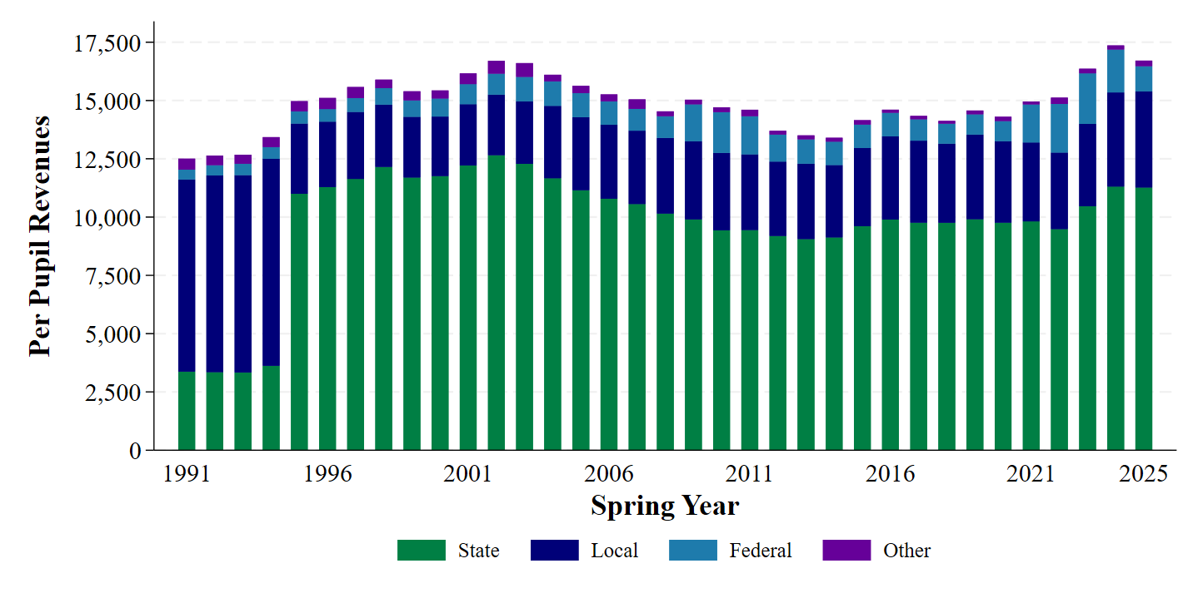
Panel B: Average School District Per Pupil Expenditures by Expenditure Type
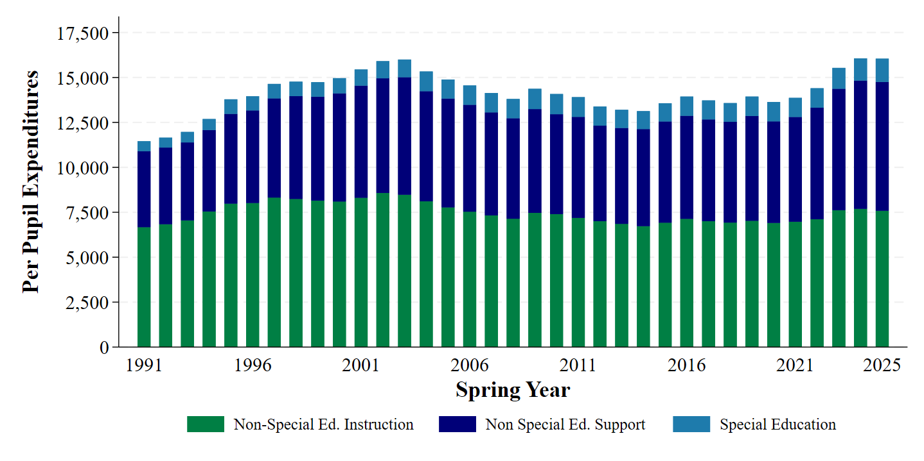
Notes: Average per pupil revenues and expenditures in Michigan school districts, 1990-91 through 2024-25 school years. Revenue data and district-level enrollment collected from Michigan Department of Education Bulletin 1014. Expenditure data collected from Michigan School District Financial Form B and the Financial Information Database. All dollar values adjusted to 2025 dollars using the GDP S&L price deflator.

Figure 2: Map of Ingham ISD and Constituent School Districts
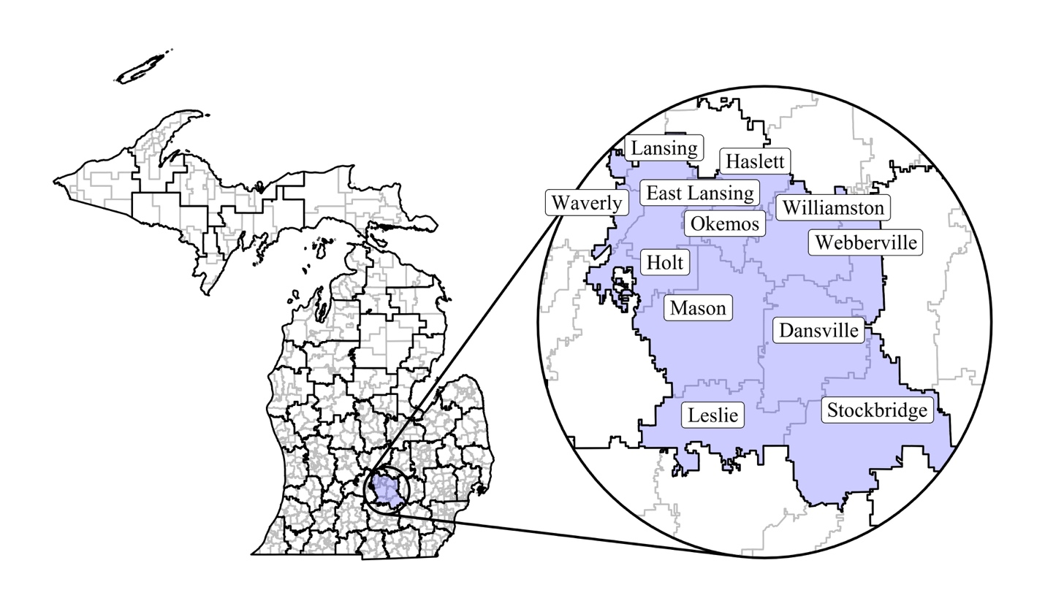
Notes: Map of Michigan school districts and Intermediate School Districts (ISDs). The left panel presents all school districts in Michigan in grey lines, and black lines identify ISDs. The inset presents Ingham ISD and the 12 constituent school districts. Ingham ISD levies an earmarked property tax for special education and coordinates special education services across the local school districts.

Figure 3: Montcalm Area ISD Total Earmarked Special Education Revenues by Source, 2003-04 through 2024-25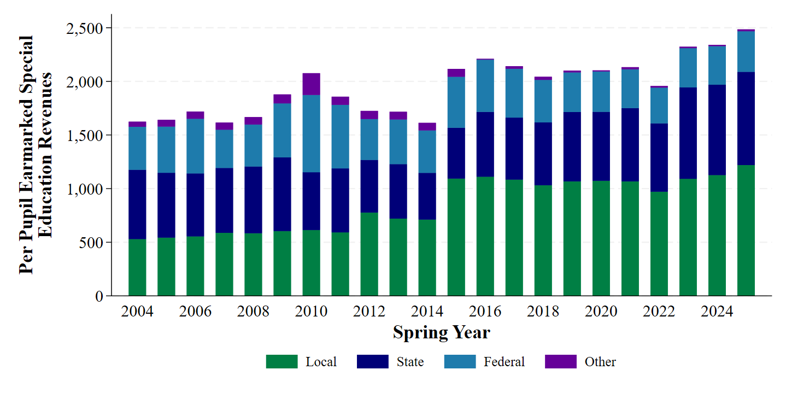
Notes: Total earmarked revenues for special education per pupil by source for Montcalm Area ISD between 2003-04 and 2024-25. Montcalm Area ISD adopted a new property tax for special education in 2014, and the revenue from this tax increase was observed during the 2014-15 academic year. In this year, local revenues for special education increased sharply and remained elevated until the end of the sample period. All dollar values adjusted to 2025 dollars using the GDP S&L price deflator.

Figure 4: ISD Responses to Increases in Earmarked Special Education Revenues
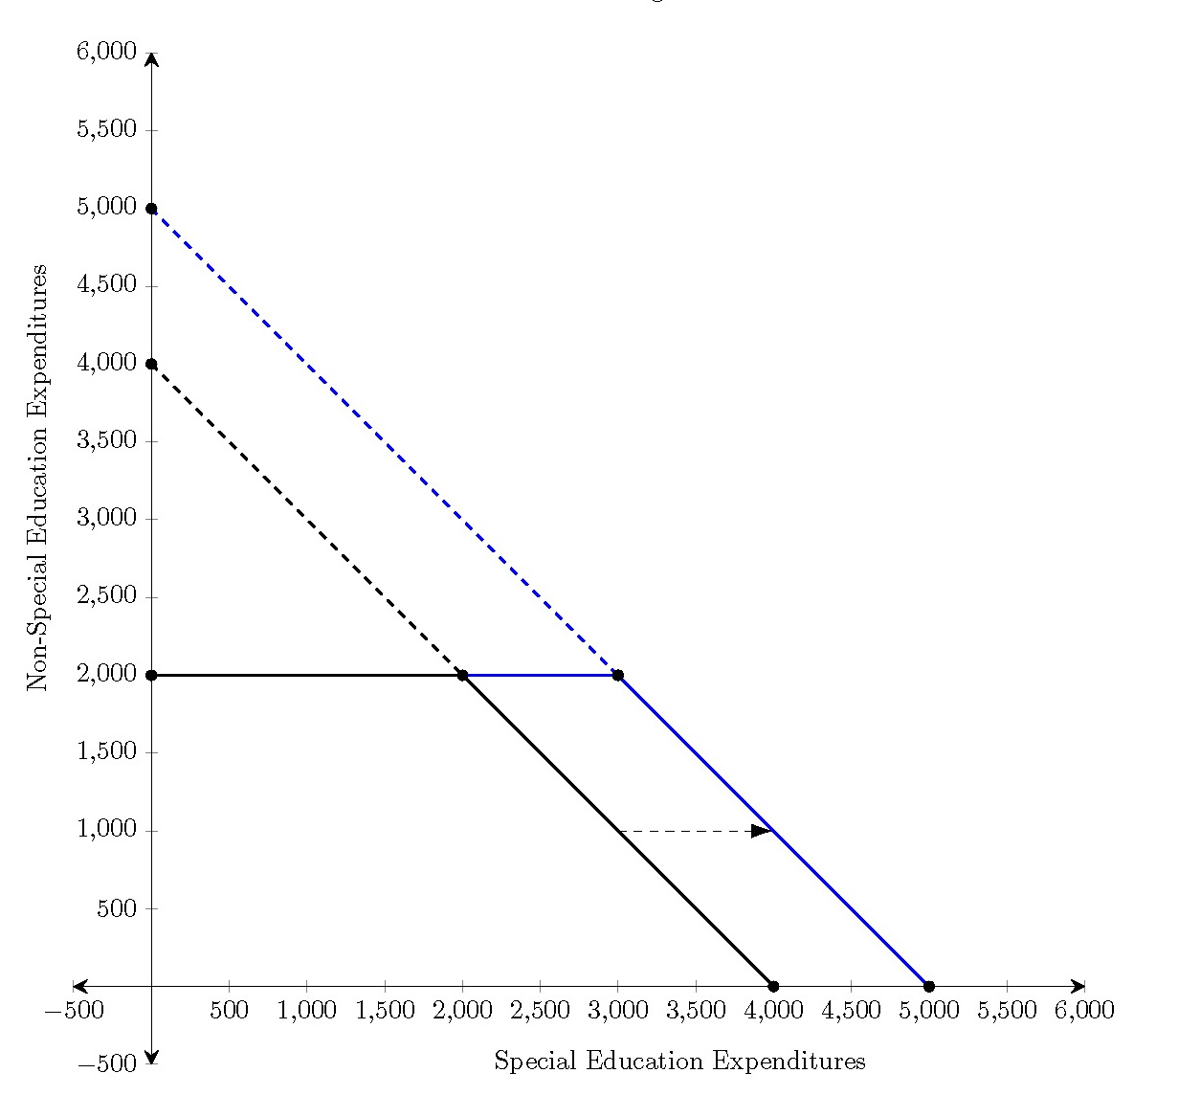
Notes: Figure illustrates the Intermediate School District’s budget constraint before and after the special education property tax change. Prior to the change, the ISD’s budget constraint follows the black line. The ISD cannot use any earmarked revenues for non-special education purposes, and so their budget constraint is flat below the minimum of the restricted special education revenue. After the property tax change, the ISD moves to the blue budget constraint with greater restricted revenues for special education.

Table 1: Summary of ISD-Level Financial and Student Demographic Data, 2003-04 through 2024-25 Academic Years
 | Control ISDs | Treated ISDs
Revenues
Total Revenue Per-Pupil | $3,182.51 | $3,159.87
 | ($1,055.73) | ($1,236.08)
Total Special Education Rev. Per-Pupil | $1,815.86 | $1,964.36
 | ($620.06) | ($502.61)
Local Special Education Rev. Per-Pupil | $764.36 | $918.06
 | ($302.24) | ($335.16)
Expenditures
Special Education Exp. Per-Pupil | $1,415.86 | $1,437.32
 | ($617.15) | ($482.82)
Special Education Per Pupil Transfers to Districts | $299.30 | $449.15
 | ($258.60) | ($464.37)
Special Education Millage | 2.14 | 2.59
 | (0.90) | (1.11)
Special Education Millage Increase | - | 0.61
 | - | (0.50)
Student Demographics
Female | 0.48 | 0.48
 | (0.01) | (0.01)
Black | 0.05 | 0.06
 | (0.07) | (0.08)
Hispanic/Latino | 0.06 | 0.06
 | (0.06) | (0.05)
Asian | 0.01 | 0.01
 | (0.01) | (0.01)
Other Race/Ethnicity | 0.04 | 0.06
 | (0.03) | (0.07)
Economically Disadvantaged | 0.51 | 0.49
 | (0.11) | (0.13)
English Learner | 0.01 | 0.02
 | (0.03) | (0.03)
Special Education | 0.17 | 0.17
 | (0.02) | (0.03)
Total Students with Disabilities | 965,472 | 1,634,375
Total Students | 5,782,988 | 10,140,689
Total ISDs | 16 | 26
Notes: ISD-level analytic sample summary statistics, 2003-04 through 2024-25 academic years. Financial data collected from the Michigan Financial Information Database. Student characteristics collected from student-level data. In the case that an ISD adopts a second property tax for special education during the sample period, data for years following the second adoption are removed from the sample. All dollar values adjusted to 2025 dollars using the GDP S&L price deflator.
Table 2: Average Causal Response of ISD-Level Local Per-Pupil Special Education Revenues following Earmarked Property Tax Increases
 | (1) | (2) | (3) | (4)
ACR | 315.480*** | 376.556*** | 268.464*** | 283.091***
 | (45.419) | (45.034) | (7.669) | (19.848)
Percent Female |  | 872.301 |  | 748.876
 |  | (916.419) |  | (1370.333)
Percent Non-White |  | -284.259 |  | -624.646
 |  | (515.341) |  | (628.436)
Percent Econ. Disad. |  | -173.005 |  | -106.664
 |  | (205.443) |  | (263.453)
Percent Special Education |  | 948.957* |  | 1241.434*
 |  | (470.093) |  | (617.691)
Log ISD Enrollment |  | -629.504*** |  | -573.134**
 |  | (137.586) |  | (227.944)
Millage Rate Functional Form | Linear | Linear | Quadratic | Quadratic
Observations | 851 | 851 | 643 | 643
Notes: Average causal response estimates from Equation (1) aggregated using the weighted average of estimates in Equation (2). Dosage represents a continuous measure of the increase in the millage of the special education property tax in each ISD. Columns (1) and (2) present estimates from models with the dosage in a linear functional form, and columns (3) and (4) present models with a quadratic functional form. All standard errors clustered at the ISD-level and unconditional on covariates. * p < 0.1, ** p < 0.05, *** p < 0.01

Figure 5: Event Study of ISD-Level Per Pupil Local Revenues for Special Education following Earmarked Property Tax Increases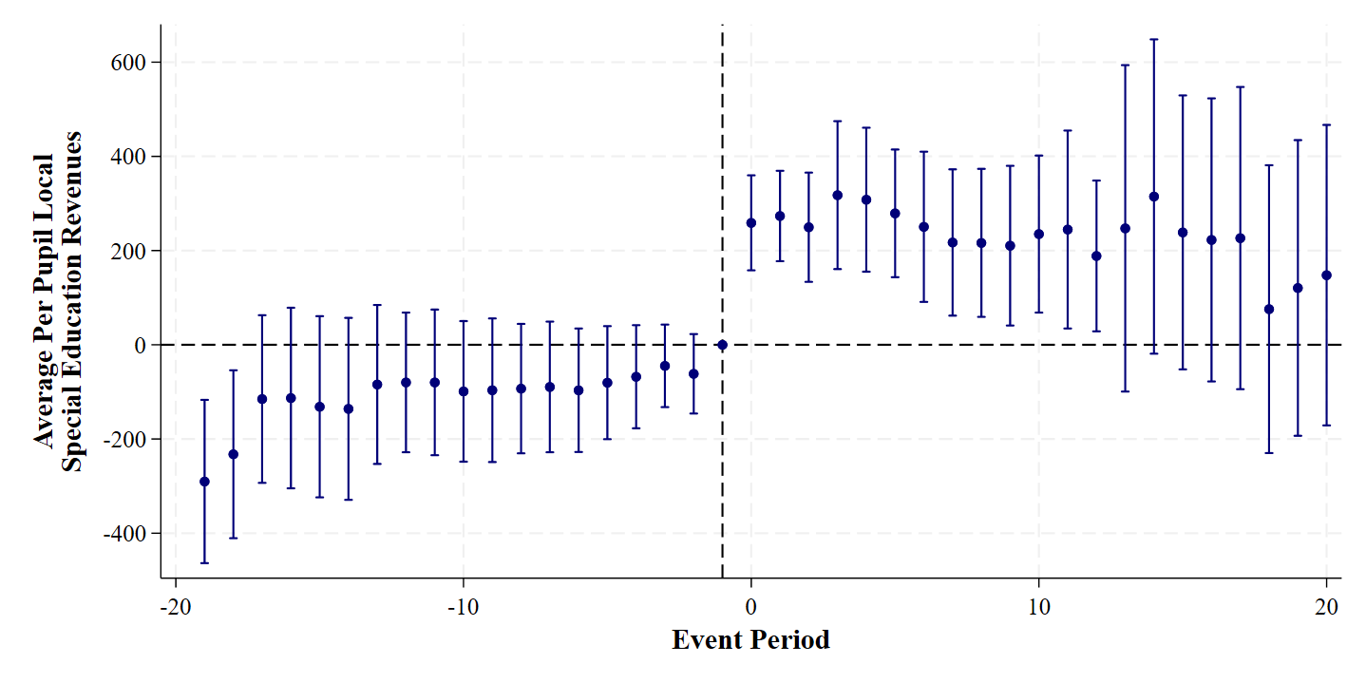
Notes: Event study estimates and 95% confidence intervals of the effects of local property tax increases on ISD-level special education revenues from Equation (3). This model uses a linear functional form for the dosage of treatment and includes all covariates. All standard errors clustered at the ISD-level and unconditional on covariates.

Table 3: Robustness of Average Causal Response of ISD-Level Local Per-Pupil Special Education Revenues following Earmarked Property Tax Increases
 | (1) | (2) | (3) | (4) | (5) | (6) | (7) | (8) | (9) | (10) | (11)
 | Base Model | Lag of Per Pupil Spending | Poisson Regression | Interact with Demeaned Covariates | Binary Treatment | TWFE | Balanced Panel | Cengiz et al. (2019) Stacked | CH WAS Estimator | SDID with Binary Treatment | Levelled Treatment
Dosage | 376.556*** | 238.934*** | 393.657*** | 404.022*** | 181.475*** | 317.874*** | 351.736*** | 339.217*** | 307.542*** | 142.473**
 | (45.034) | (32.784) | (45.911) | (52.986) | (36.034) | (38.472) | (41.367) | (42.973) | (24.623) | (64.359)
Low Dosage |  |  |  |  |  |  |  |  |  |  | 72.118***
 |  |  |  |  |  |  |  |  |  |  | (23.568)
High Dosage |  |  |  |  |  |  |  |  |  |  | 223.492***
 |  |  |  |  |  |  |  |  |  |  | (24.908)
Functional Form | Linear | Linear | Linear | Linear | N/A | Linear | Linear | Linear | Linear | N/A | N/A
Observations | 851 | 738 | 851 | 851 | 851 | 851 | 704 | 5597 | 579 | 704 | 851
Notes: Robustness checks of average causal response estimates from Equation (1) aggregated using the weighted average of estimates in Equation (2). Dosage represents a continuous measure of the increase in the millage of the special education property tax in each ISD. All standard errors clustered at the ISD-level. * p < 0.1, ** p < 0.05, *** p < 0.01

Table 4: Average Causal Response of ISD-Level Special Education Expenditures and Transfers following Earmarked Property Tax Increases
 | Per Pupil Special Education Expenditures |  | Per Pupil Transfers of Special Education Funding to Local School Districts
 | (1) | (2) | (3) | (4)
ACR | 124.116* | 171.830*** | 191.189*** | 256.523***
 | (63.365) | (41.184) | (67.448) | (25.656)
Percent Female | 1794.992 | 103.279 | 934.966 | 3705.856
 | (3221.721) | (4307.454) | (2593.371) | (2638.525)
Percent Non-White | 325.956 | -373.698 | 51.066 | -1005.361
 | (929.303) | (1036.419) | (1288.490) | (807.400)
Percent Econ. Disad. | -627.939* | -731.859* | 578.783 | 501.672
 | (333.901) | (428.940) | (383.296) | (407.542)
Percent SWD | 2055.262** | 1020.842 | -479.262 | 1517.210**
 | (879.405) | (1218.017) | (1057.896) | (704.458)
Log ISD Enrollment | -835.562*** | -535.116 | -181.965 | -450.713
 | (229.127) | (345.053) | (224.848) | (267.173)
Millage Rate Functional Form | Linear | Quadratic | Linear | Quadratic
Observations | 851 | 643 | 851 | 643
Notes: Average causal response estimates from Equation (1) aggregated using the weighted average of estimates in Equation (2). Dosage represents a continuous measure of the increase in the millage of the special education property tax in each ISD. Columns (1) and (2) present estimates from models with the dosage in a linear functional form, and columns (3) and (4) present models with a quadratic functional form. All standard errors clustered at the ISD-level and unconditional on covariates. * p < 0.1, ** p < 0.05, *** p < 0.01

Figure 6: Event Study of ISD-Level Per Pupil Special Education Expenditures following Earmarked Property Tax Increase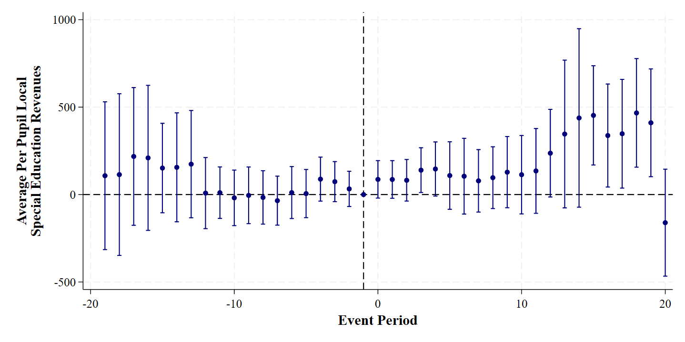
Notes: Event study estimates and 95% confidence intervals of the effects of local property tax increases on ISD-level special education expenditures from Equation (3). This model uses a linear functional form for the dosage of treatment and includes all covariates. All standard errors clustered at the ISD-level and unconditional on covariates.

Table 5: Average Causal Response of School District-Level Special Education Expenditures following Earmarked Property Tax Increases
 | Per Pupil Special Education Expenditures |  | Per Pupil Non-Special Education Expenditures
 | (1) | (2) | (3) | (4)
ACR | -17.722 | 36.662 | 223.233** | 76.531
 | (92.280) | (47.300) | (93.073) | (50.245)
Percent Female | -690.078 | -1242.719 | 2484.766 | 3099.393
 | (797.204) | (741.079) | (1854.259) | (2102.277)
Percent Non-White | 477.118 | 627.362 | -622.032 | -775.859
 | (637.797) | (658.416) | (1074.301) | (1277.651)
Percent Econ. Disad. | 334.726* | 319.578 | 661.006 | 584.212
 | (181.945) | (208.787) | (417.111) | (458.143)
Percent SWD | 9211.559*** | 9515.500** | 814.897 | 1382.768
 | (3304.262) | (4014.664) | (1335.716) | (1672.595)
Log ISD Enrollment | 564.947* | 523.789 | -616.381* | -446.451
 | (310.719) | (360.662) | (329.558) | (340.688)
Millage Rate Functional Form | Linear | Quadratic | Linear | Quadratic
Observations | 7577 | 5956 | 7577 | 5956
Notes: Average causal response estimates from Equation (1) aggregated using the weighted average of estimates in Equation (2). Dosage represents a continuous measure of the increase in the millage of the special education property tax in each ISD. Columns (1) and (2) present estimates from models with the dosage in a linear functional form, and columns (3) and (4) present models with a quadratic functional form. All standard errors clustered at the ISD-level and unconditional on covariates. * p < 0.1, ** p < 0.05, *** p < 0.01

Table 6: Average Causal Response of School District-Level Non-Special Education Expenditures following Earmarked Property Tax Increase, by Expenditure Type
 | Salaries | Benefits | Purchased Services | Supplies | Transfers to School Districts/ ISDs | Other
 | (1) | (2) | (3) | (4) | (5) | (6)
ACR | 313.197*** | -12.632 | -230.581*** | 43.168*** | 120.161** | -10.080
 | (69.668) | (44.061) | (54.242) | (12.579) | (47.759) | (8.750)
Percent Female | 1981.490** | 1219.671* | -1094.842 | -477.924 | 692.885 | 163.486
 | (903.048) | (613.620) | (1671.771) | (460.512) | (599.959) | (256.789)
Percent Non-White | -1690.399* | -344.832 | 462.563 | -24.911 | 829.100 | 146.446***
 | (894.834) | (573.055) | (444.362) | (190.387) | (519.482) | (35.355)
Percent Econ. Disad. | 423.379 | 19.010 | 4.577 | 71.361 | 152.019** | -9.340
 | (321.135) | (126.505) | (150.246) | (80.347) | (68.737) | (28.163)
Percent SWD | 963.307 | -64.465 | -344.995 | 263.347 | -79.048 | 76.752
 | (911.753) | (610.041) | (813.820) | (215.179) | (420.576) | (109.422)
Log Dist. Enrollment | 1080.541*** | 529.146*** | -1868.648*** | -264.802*** | -52.981 | -39.638*
 | (368.725) | (189.032) | (330.978) | (75.226) | (48.291) | (21.467)
Observations | 7577 | 7577 | 7577 | 7577 | 7577 | 7577
Notes: Average causal response estimates from Equation (1) aggregated using the weighted average of estimates in Equation (2). Dosage represents a continuous measure of the increase in the millage of the special education property tax in each ISD. Columns (1) and (2) present estimates from models with the dosage in a linear functional form, and columns (3) and (4) present models with a quadratic functional form. All standard errors clustered at the ISD-level and unconditional on covariates. * p < 0.1, ** p < 0.05, *** p < 0.01

Table A1: Summary of District-Level Financial and Student Demographic Data, 2003-04 through 2024-25 Academic Years
 | Control ISDs | Treated ISDs
Total General Revenue Per Pupil | 14,179.43 | 16,205.75
 | (2,723.80) | (9,296.82)
Total Revenue from ISD Per Pupil | 273.78 | 522.24
 | (370.20) | (643.30)
Special Education Exp. Per Pupil | 1,171.29 | 1,212.47
 | (521.98) | (687.81)
Female | 0.48 | 0.48
 | (0.03) | (0.05)
Black | 0.08 | 0.07
 | (0.19) | (0.15)
Hispanic/Latino | 0.05 | 0.07
 | (0.05) | (0.10)
Asian | 0.01 | 0.01
 | (0.01) | (0.02)
Other Race/Ethnicity | 0.04 | 0.06
 | (0.06) | (0.10)
Economically Disadvantaged | 0.52 | 0.49
 | (0.19) | (0.21)
English Learner | 0.01 | 0.02
 | (0.02) | (0.06)
Special Education | 0.15 | 0.15
 | (0.04) | (0.06)
Total Students with Disabilities | 811,529 | 1,401,112
Total Students | 5,406,174 | 9,336,117
Total Districts | 129 | 267
Notes: District-level analytic sample summary statistics, 2003-04 through 2024-25 academic years. Financial data collected from the Michigan Financial Information Database. Student characteristics collected from student-level data. In the case that an ISD adopts a second property tax for special education during the sample period, data for years following the second adoption are removed from the sample. All dollar values adjusted to 2025 dollars using the GDP S&L price deflator.

Table A2: Robustness of Average Causal Response of ISD-Level Local Per-Pupil Special Education Revenues following Earmarked Property Tax Increases, Ever-Treated Sample
 | (1) | (2) | (3) | (4) | (5) | (6) | (7) | (8)
 | Base Model | Lag of Per Pupil Spending | Poisson Regression | Interact with Demeaned Covariates | Binary Treatment | TWFE | Balanced Panel | CH WAS Estimator
Dosage | 341.701*** | 233.761*** | 350.769*** | 352.562*** | 167.463*** | 294.890*** | 334.711*** | 302.467***
 | (61.090) | (48.108) | (62.424) | (69.977) | (41.234) | (38.425) | (43.056) | (29.219)
Functional Form | Linear | Linear | Linear | Linear | N/A | Linear | Linear | Linear
Observations | 512 | 415 | 512 | 512 | 512 | 512 | 374 | 348
Notes: Robustness checks of average causal response estimates from Equation (1) aggregated using the weighted average of estimates in Equation (2). Dosage represents a continuous measure of the increase in the millage of the special education property tax in each ISD. All standard errors clustered at the ISD-level. * p < 0.1, ** p < 0.05, *** p < 0.01

Table A3: Robustness of Average Causal Response of ISD-Level Per-Pupil Special Education Expenditures following Earmarked Property Tax Increases
 | (1) | (2) | (3) | (4) | (5) | (6) | (7) | (8) | (9) | (10)
 | Base Model | Lag of Per Pupil Spending | Poisson Regression | Interact with Demeaned Covariates | Binary Treatment | TWFE | Balanced Panel | Cengiz et al. (2019) Stacked | CH WAS Estimator | SDID with Binary Treatment
Dosage | 124.116* | 10.155 | 76.357* | 45.704 | 42.941 | 33.884 | 38.997 | 36.535 | 16.695 | 27.279
 | (63.365) | (20.377) | (39.592) | (75.215) | (36.715) | (27.822) | (53.699) | (37.375) | (23.691) | (101.910)
Functional Form | Linear | Linear | Linear | Linear | N/A | Linear | Linear | Linear | Linear | N/A
Observations | 851 | 738 | 851 | 851 | 851 | 851 | 704 | 5597 | 579 | 704
Notes: Robustness checks of average causal response estimates from Equation (1) aggregated using the weighted average of estimates in Equation (2). Dosage represents a continuous measure of the increase in the millage of the special education property tax in each ISD. All standard errors clustered at the ISD-level. * p < 0.1, ** p < 0.05, *** p < 0.01

Table A4: Robustness of Average Causal Response of ISD-Level Per-Pupil Special Education Transfers to Local School Districts following Earmarked Property Tax Increases
 | (1) | (2) | (3) | (4) | (5) | (6) | (7) | (8) | (9) | (10)
 | Base Model | Lag of Per Pupil Transfers | Poisson Regression | Interact with Demeaned Covariates | Binary Treatment | TWFE | Balanced Panel | Cengiz et al. (2019) Stacked | CH WAS Estimator | SDID with Binary Treatment
Dosage | 194.884*** | 69.957* | 130.828*** | 227.703*** | 98.861* | 160.437** | 182.018* | 177.067** | 129.517* | 45.911
 | (69.937) | (38.866) | (48.500) | (60.556) | (51.084) | (66.186) | (91.696) | (69.079) | (70.352) | (87.325)
Functional Form | Linear | Linear | Linear | Linear | N/A | Linear | Linear | Linear | Linear | N/A
Observations | 830 | 717 | 830 | 830 | 830 | 830 | 594 | 5352 | 560 | 594
Notes: Robustness checks of average causal response estimates from Equation (1) aggregated using the weighted average of estimates in Equation (2). Dosage represents a continuous measure of the increase in the millage of the special education property tax in each ISD. All standard errors clustered at the ISD-level. * p < 0.1, ** p < 0.05, *** p < 0.01

Table A5: Average Causal Response of ISD-Level Special Education Expenditures following Earmarked Property Tax Increase, by Expenditure Type
 | Salaries | Benefits | Purchased Services | Supplies | Other
 | (1) | (2) | (3) | (4) | (5)
ACR | 95.565** | 51.832 | -25.013 | -19.672*** | 8.135
 | (36.215) | (34.915) | (31.840) | (3.615) | (7.760)
Percent Female | -614.295 | 1435.065 | 2025.981** | -142.688 | -15.887
 | (1555.473) | (1316.235) | (949.286) | (263.071) | (445.426)
Percent Non-White | -678.988 | -211.804 | 1051.058* | -108.693 | -132.793
 | (571.715) | (476.291) | (598.668) | (88.607) | (177.071)
Percent Econ. Disad. | -470.540** | -335.530** | -330.392** | 0.110 | 107.749
 | (183.840) | (130.899) | (152.683) | (21.850) | (109.181)
Percent SWD | 1998.603*** | 865.582** | 665.056* | 104.911* | 50.479
 | (438.096) | (378.980) | (388.943) | (56.273) | (173.716)
Log Dist. Enrollment | -320.398** | -323.239** | -340.814** | -5.185 | -54.338
 | (123.328) | (136.509) | (139.920) | (15.818) | (41.830)
Observations | 851 | 851 | 851 | 851 | 851
Notes: Average causal response estimates from Equation (1) aggregated using the weighted average of estimates in Equation (2). Dosage represents a continuous measure of the increase in the millage of the special education property tax in each ISD. All standard errors clustered at the ISD-level and unconditional on covariates. * p < 0.1, ** p < 0.05, *** p < 0.01

Table A6: Average Causal Response of School District-Level Revenues from ISD following Earmarked Property Tax Increases
 | Per Pupil Revenues from ISD
 | (1) | (2)
ACR | 368.750*** | 203.345***
 | (70.414) | (60.620)
Percent Female | -337.900 | -65.676
 | (521.479) | (538.988)
Percent Non-White | -180.421 | -207.053
 | (490.247) | (565.083)
Percent Econ. Disad. | 110.589 | 134.621
 | (156.417) | (187.935)
Percent SWD | 166.175 | 426.679
 | (443.943) | (565.242)
Log ISD Enrollment | 176.296 | 252.058*
 | (133.878) | (143.802)
Millage Rate Functional Form | Linear | Quadratic
Observations | 7577 | 5956
Notes: Average causal response estimates from Equation (1) aggregated using the weighted average of estimates in Equation (2). Dosage represents a continuous measure of the increase in the millage of the special education property tax in each ISD. Columns (1) and (2) present estimates from models with the dosage in a linear functional form, and columns (3) and (4) present models with a quadratic functional form. All standard errors clustered at the ISD-level and unconditional on covariates. * p < 0.1, ** p < 0.05, *** p < 0.01

Table A7: Average Causal Response of School District-Level Special Education Expenditures following Earmarked Property Tax Increase, by Expenditure Type
 | Salaries | Benefits | Purchased Services | Supplies | Payments to School Districts/ ISDs | Other
 | (1) | (2) | (3) | (4) | (5) | (6)
ACR | -38.312 | -11.511 | 5.299 | -1.343 | 10.684* | -34.597
 | (26.432) | (10.759) | (3.181) | (0.902) | (6.310) | (52.228)
Rural | -349.220 | -215.141 | -14.276 | -8.964 | -68.990 | 191.837
 | (287.049) | (182.625) | (13.290) | (9.176) | (54.773) | (485.827)
Percent Female | 311.943 | 150.936 | 29.697 | 10.394 | 66.165 | -315.495
 | (254.850) | (118.804) | (20.962) | (8.545) | (44.832) | (277.324)
Percent Non-White | 129.079 | 38.386* | 24.295 | 4.752 | -3.964 | 345.141**
 | (79.150) | (19.435) | (17.746) | (3.278) | (15.166) | (154.449)
Percent Econ. Disad. | 1943.978 | 1134.841 | 183.111 | 62.796 | 500.785 | 5025.670***
 | (1623.554) | (959.945) | (154.048) | (51.812) | (428.240) | (829.057)
Percent SWD | 148.614 | 73.515 | 13.296 | 4.958 | 18.564 | 267.074
 | (140.966) | (68.213) | (13.018) | (4.881) | (15.731) | (160.764)
Log Dist. Enrollment | -38.312 | -11.511 | 5.299 | -1.343 | 10.684* | -34.597
 | (26.432) | (10.759) | (3.181) | (0.902) | (6.310) | (52.228)
Observations | 7577 | 7577 | 7577 | 7577 | 7577 | 7577
Notes: Average causal response estimates from Equation (1) aggregated using the weighted average of estimates in Equation (2). Dosage represents a continuous measure of the increase in the millage of the special education property tax in each ISD. Columns (1) and (2) present estimates from models with the dosage in a linear functional form, and columns (3) and (4) present models with a quadratic functional form. All standard errors clustered at the ISD-level and unconditional on covariates. * p < 0.1, ** p < 0.05, *** p < 0.01

Table A8: Average Causal Response of School District-Level Special Education Expenditures following Earmarked Property Tax Increases Among Rural School Districts
 | Salaries | Benefits | Purchased Services | Supplies | Payments to School Districts/ ISDs | Other
 | (1) | (2) | (3) | (4) | (5) | (6)
ACR | 208.27*** | -12.48 | -133.79** | 10.91 | 30.43* | -21.37
 | (52.40) | (33.05) | (52.39) | (10.71) | (16.61) | (14.98)
Rural | 227.12*** | 12.10 | -101.30* | 5.49 | -27.07 | -12.04
 | (67.88) | (46.76) | (56.95) | (15.71) | (24.17) | (16.99)
Percent Female | 1957.15** | 1172.72* | -1202.20 | -510.25 | 612.67 | 175.50
 | (880.26) | (612.23) | (1657.36) | (451.07) | (611.09) | (259.25)
Percent Non-White | -2081.95** | -484.85 | 535.00 | -0.96 | 862.73 | 149.38***
 | (925.60) | (587.89) | (422.97) | (187.97) | (521.77) | (32.54)
Percent Econ. Disad. | 356.43 | -31.39 | -4.72 | 76.62 | 110.02 | -10.42
 | (352.43) | (142.81) | (153.70) | (79.49) | (66.54) | (28.87)
Percent SWD | 777.46 | -217.61 | -380.65 | 265.49 | -189.02 | 88.74
 | (902.09) | (581.04) | (799.79) | (221.00) | (446.24) | (110.83)
Log Dist. Enrollment | 1120.59*** | 552.50*** | -1863.51*** | -270.66*** | -46.01 | -39.09*
 | (358.18) | (183.48) | (332.88) | (74.65) | (48.00) | (22.63)
Observations | 7575 | 7575 | 7575 | 7575 | 7575 | 7575
Notes: Average causal response estimates from Equation (1) aggregated using the weighted average of estimates in Equation (2). Dosage represents a continuous measure of the increase in the millage of the special education property tax in each ISD. Columns (1) and (2) present estimates from models with the dosage in a linear functional form, and columns (3) and (4) present models with a quadratic functional form. All standard errors clustered at the ISD-level and unconditional on covariates. * p < 0.1, ** p < 0.05, *** p < 0.01

Figure A1: Event Study of ISD-Level Per Pupil Total Special Education Revenues following Earmarked Property Tax Increases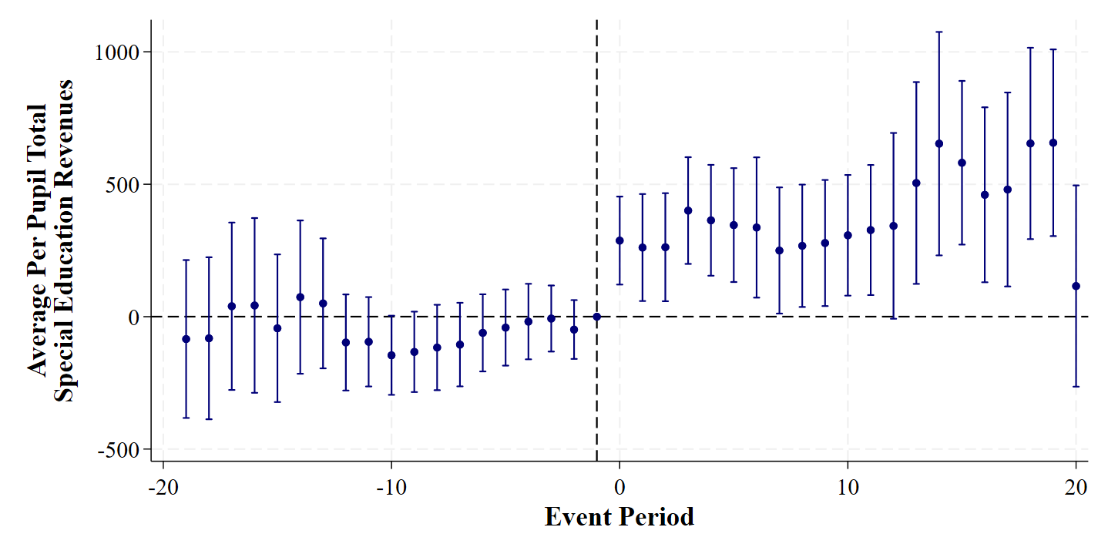
Notes: Event study estimates and 95% confidence intervals of the effects of local property tax increases on ISD-level total special education revenues from Equation (3). This model uses a linear functional form for the dosage of treatment and includes all covariates. All standard errors clustered at the ISD-level.

Figure A2: Event Study of ISD-Level Per Pupil Special Education Transfers to Local School Districts following Earmarked Property Tax Increases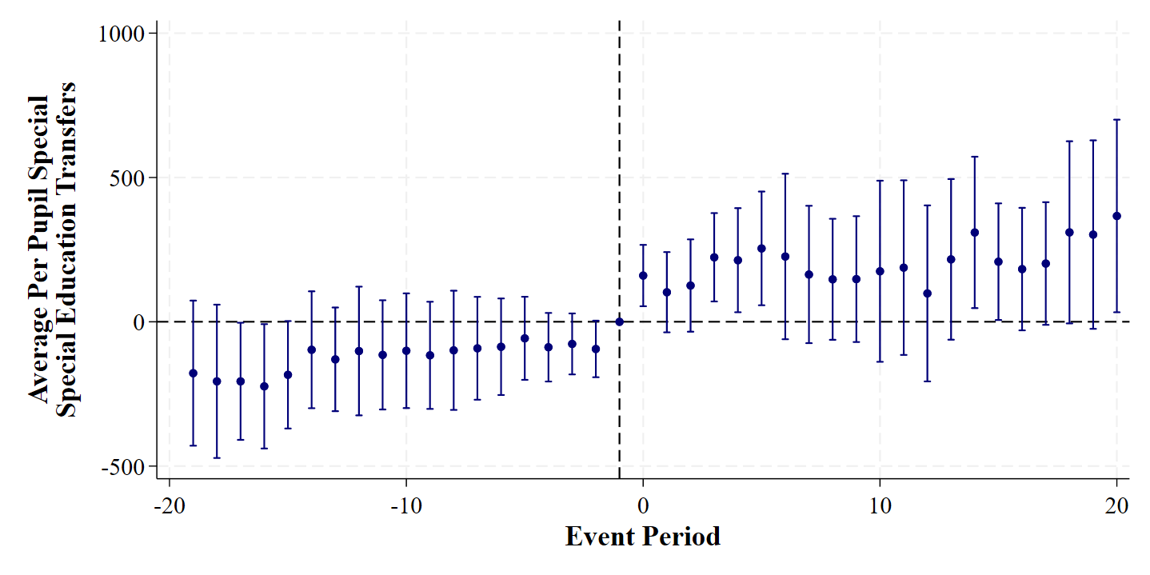
Notes: Event study estimates and 95% confidence intervals of the effects of local property tax increases on ISD-level transfers of earmarked special education revenues from Equation (3). This model uses a linear functional form for the dosage of treatment and includes all covariates. All standard errors clustered at the ISD-level.

Figure A3: Event Study of District-Level Per Pupil Special Education Expenditures following Earmarked Property Tax Increases 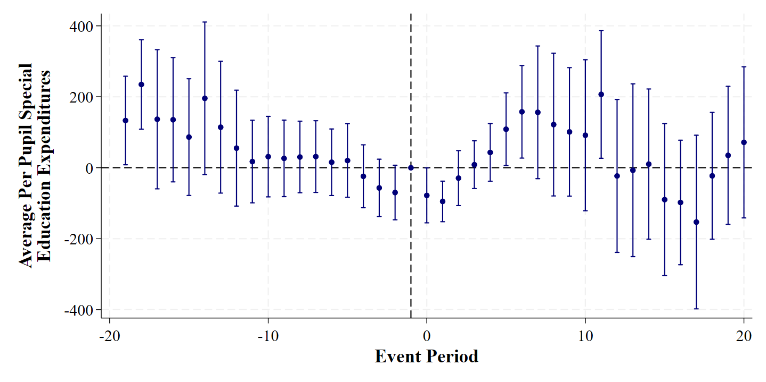
Notes: Event study estimates and 95% confidence intervals of the effects of local property tax increases on district-level special education expenditures from Equation (3). This model uses a linear functional form for the dosage of treatment and includes all covariates. All standard errors clustered at the ISD-level.

Figure A4: Event Study of District-Level Per Pupil Non-Special Education Expenditures following Earmarked Property Tax Increases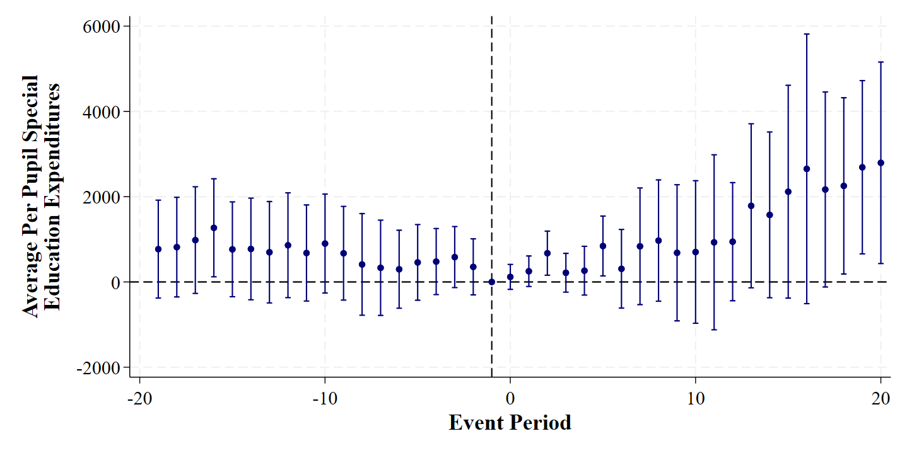
Notes: Event study estimates and 95% confidence intervals of the effects of local property tax increases on district-level non-special education expenditures from Equation (3). This model uses a linear functional form for the dosage of treatment and includes all covariates. All standard errors clustered at the ISD-level.

This research result used data structured and maintained by the MERI-Michigan Education Data Center (MEDC). MEDC data is modified for analysis purposes using rules governed by MEDC and are not identical to those data collected and maintained by the Michigan Department of Education (MDE), Michigan’s Center for Educational Performance and Information (CEPI), or Michigan's Department of Lifelong Education, Advancement, and Potential (MiLEAP). Results, information and opinions solely represent the analysis, information and opinions of the author(s) and are not endorsed by, or reflect the views or positions of, grantors, MDE, CEPI, MiLEAP or any employee thereof.
See also Gadenne (2017).
See also Tsang & Levin (1983), Evans et al. (1997), Goertz & Natriello (1999), Gordon (2004), and Hoxby (2001).
Craig & Inman (1982) explore this type of grant at the state-level, and they find that conditional grants tend to increase spending in areas separate from the categories they are intended to support.
Property tax rates in Table 1 are provided in millage rates. A 1 mill property tax is equivalent to $1 for every $1,000 of property value.
All dollar values are adjusted to 2025 dollars using the GDP S&L price deflator (Burns & Guzman, 2025; Arsen et al., 2019).
ISDs distribute these resources to districts primarily on the basis of total special education costs, the share of SWDs in the district, and the share of total students in the ISD (Nagel, 2021).
Arsen et al. (2019) observe that this structure is inherently unequal as ISDs vary widely in both their property tax bases and the number of SWDs they serve. Further, this contributes to variation in the amounts of funding ISDs must draw from general funds or elsewhere to provide appropriate services to SWDs.
Arsen et al. (2019) note that this maximum is relatively arbitrary as it is defined by the property tax level in each ISD in 1994.
These property taxes may be either “millage renewals” or a “millage restorations.” As a result of the Headlee Amendment adopted in 1978, property tax rates decline each year to ensure that they do not collect more revenue than was approved at the time of the tax election, accounting for inflation. As a result, special education millages may decline over time and need to be “restored” if they decline significantly before the millage expires. I do not consider differences in these types of property tax increases here.
Note that while I have data in the 2002-03 academic year, I need ISDs to not have adopted a new property tax in 2002-03 so that they are not “always treated” units.
This example draws on Bradford & Shaviro (2000) and Shah (2006).
In Michigan, a student FTE is defined as a fractional value between 0 and 1 indicating the proportion of 1,098 minimum total instructional hours a student is scheduled to receive. This value is also separated for the amount of time spent in general education and special education services. For example, if a student were scheduled to receive special education programming for 1 hour per week and general education instruction for the rest of the week, this would equate to a 0.03 FTE in special education and 0.97 FTE in general education. This approach avoids double counting students if they appear in both a general education and special education program in the same school district.
This is similar to Equation 5.6 in Wooldridge (2025), although I restrict treatment heterogeneity by not including interaction terms with time dummies or with covariates.
Formally, I weight the $γ_{g}$ in Equation (1) using the following equation to compute the average causal response (ACR), and I compute unconditional standard errors for all aggregated estimates: $ACR= \sum_{g=1}^{G}{\frac{N_{g}γ_{g}}{N}}$ (2). This is similar to Equation 7.3 in Wooldridge (2025), although I restrict treatment heterogeneity and I do not include interactions between the cohort indicators and all time dummies.
This effect should be interpreted as the marginal effect of an increase in the property tax rate on the outcome, and I interpret this as an increase of 1 mill in the property tax rate. However, the average special education property tax increase during my sample period is 0.61 mills, so the revenue impact is smaller for the average ISD.
This is equal to the average causal response of $376.56 multiplied by the average treatment intensity of 0.61 mills.
This provides some justification for not including cohort indicators in my event study model. Variation in estimated effects across cohorts appears to have a minimal effect on the average causal response.
Note that this estimator drops time periods in which there is no unit that switches treatment. As a result, the observation count is smaller in this specification relative to the full sample.
An event study of transfers is provided in Appendix Figure A2, and this illustrates smooth pre-trends for this outcome as well.
In addition, I drop 67 school district-year observations that have no reported expenditures for non-special education purposes. These observations relate to school districts are specialized and may only support students with disabilities in given year.
In Appendix Table A6, I also estimate the effect of school district-level per pupil revenues received from the ISD following the property tax change. These estimates are closely aligned with those of the transfers in Table 4.
I estimate similar models for special education expenditures in Appendix Table A7, although I do not find any significant trends.

